Groupon Report

YipitData Product Development Specialist Assignment

Brian Chan

July 21st, 2021

**Part 1**

Gross Billings 4Q13/Work shown

In the fourth quarter of 2013, Groupon has amassed hundreds of millions of dollars in gross billings in three major sectors – local, goods, and travel billings. The breakdown of these billings include:

* **October Total Gross Billings: $144,298,554.21**
  + **Local Billings: $61,591,306.81**
  + **Goods Billings: $62,470213.89**
  + **Travel billings: $20,237,033.51**
* **November Total Gross Billings: $241,868,240.37**
  + **Local Billings: $101,766,642.04**
  + **Goods Billings: $115,005,646.40**
  + **Travel billings: $25,095,951.93**
* **December Total Gross Billings: $188,495,842.18**
  + **Local Billings: $67,018,251.06**
  + **Goods Billings: $98,789,035.29**
  + **Travel Billings: $22,688,555.83**

These figures were extracted from the csv file that was converted from excel file provided. A python script I have wrote analyzed the data from the file, then outputted it into something organized and readable. Along with the gross billings for each of the three sectors, I have also included the units sold for each sector of each month of this current quarter in case there was a need for it. The full code I have written and ran to get this data along with the output is provided below. The left side shows the actual script written, while the right side shows the 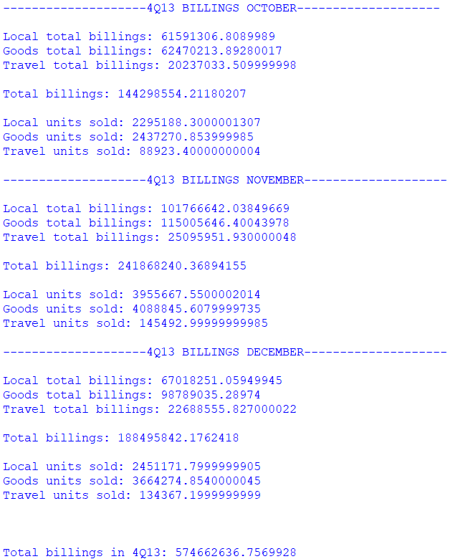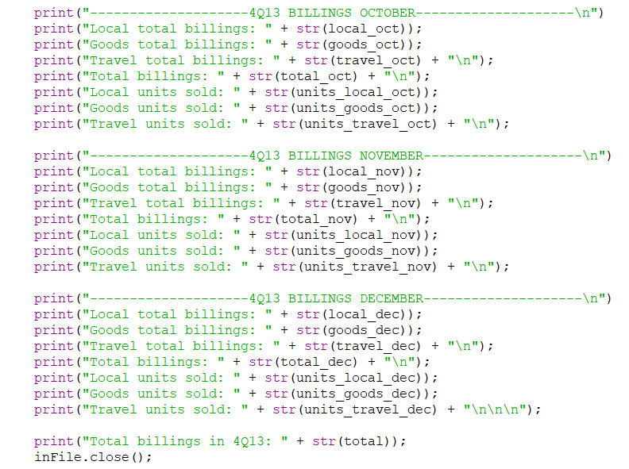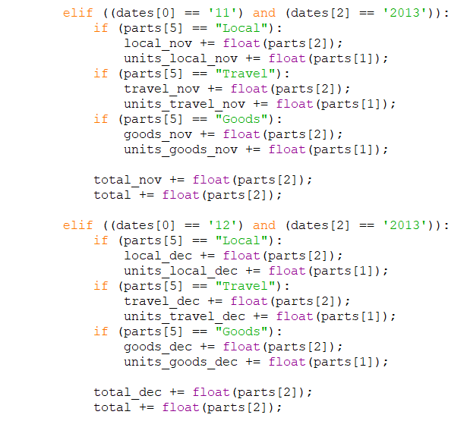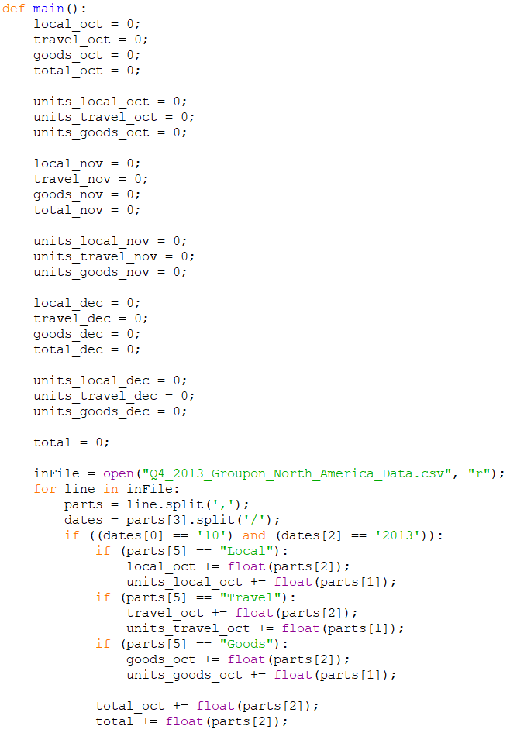data in an organized fashion.

One important thing to note when calculating these estimates is the data shows entries of EVERY SINGLE transaction that was active during the three-month span from October 1st to December 31st, 2013. To get the gross billings estimate, it was imperative to filter out entries with transaction starting dates not within this time frame. The gross billings for this quarter should ONLY consider transactions started within these three months.

Potential Problems

The data received had one major problem with it, which was the fact that the system that collected this data from Groupon went offline for 10 days, spanning the 20th of October 2013 to the 30th of October 2013. While offline, it was unable to collect local billing data during that time (though it was still able to collect travel and goods billings). It is important to note this predicament when looking at the data since it directly correlates to the unusually smaller number for October’s local gross billings. It can be speculated that the system lost at least one-third of the local billings data for October assuming the local billings remained constant throughout the month. Losing 10 days’ worth of entries in a single month equates to losing a third of all the entries of that month.

Seasonality is something affects numerous businesses, and Groupon is no different. According to the equity report by Deutsche Bank, estimated North American gross billing CSOI was $20 million above the true CSOI. Many factors may account for seasonality and the inaccurate estimate, but it is believed that changes to Gmail is the main component in this seasonality issue.

Equity reports from various international banks have shown the value of Groupon during the year. Three major banks, JPMorgan, Morgan Stanley, and Deutsche Bank have all remarked in their report that Groupon’s value has generally been on an upward trend. Even so, the company has faced multiple challenges during the year. One thing that has been detrimental to Groupon during the year was the Gmail predicament. Recently, Gmail has developed a system to sort emails into different groups and tabs, one of which is the “promotions” tab which Groupon emails fall under. This new feature has been detrimental to Groupon’s growth and interactions since because people are unaware or are ignoring this new tab, their Groupon emails remain unopened. Groupon has started to trend away from using push emails and into “pull” transactions and mobile use. Because of this, the system that Groupon had for emails is getting overhauled. This could be a great thing for the future, though of course it will take time to fully streamline and implement this mobile method.

Potential Positives

Groupon’s development towards “pull” and mobile transactions has made tremendous progress, and continues to do so through the year. According to the JPMorgan’s released equity report, in the third quarter of this year there has been roughly 9 million mobile downloads of the app, and in the second quarter there has been roughly 7.5 million. This positive trend shows that there is a lot of promise in Groupon transitioning into a more mobile friendly company.

Groupon’s CFO Jason Child is optimistic about the company’s future. He believes that gross billings will eventually grow by roughly 20%, which would lead to revenue and profits growing about the same amount. Child has noted that management is willing to sacrifice some marginal percentages in order to put profits into consumers, as he believes that having the money in consumers more money will flow back into Groupon as these consumers spend and would be more beneficial to the company in the long term.

Conclusion/Invest or Not?

Based on the recent trends of Groupon, my advice to potential investors is to **INVEST** in Groupon.

Provided on the next two pages are three graphs of the valuation of Groupon from the equity reports of Deutsche Bank, JPMorgan, and Morgan Stanley respectively. Generally, all three of these graphs show very similar trends and patterns: Valuation of the company starts off high but fluctuates towards the end of the fourth quarter of 2011, then takes a deep dip from the end of the first quarter of 2012 all the way to the end of the fourth quarter in 2012. Then after this dip, Groupon’s valuation starts to slowly ascend again for a whole year up until November of 2013 when Gmail added its email sorting feature which hit Groupon hard.

Investing in Groupon at this time would be a good idea because as can be seen on the graphs, Groupon’s value has been steadily rising until the Gmail incident in November. In the long run, this Gmail hiccup will hopefully fix itself as more and more people will understand how to use this new feature works. Everything takes time to learn, and this problem is nothing major to fret about. As Groupon has this slight dip, investors should be even more inclined to put money into this company. The year-long upward swing reflects the way Groupon is trending and gives way to future security and profits for investors looking to put money into a promising company.

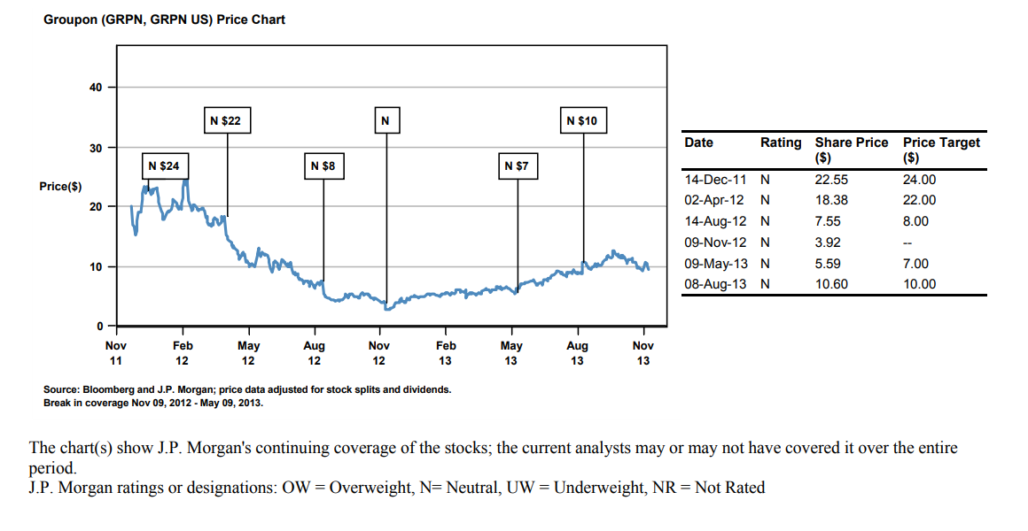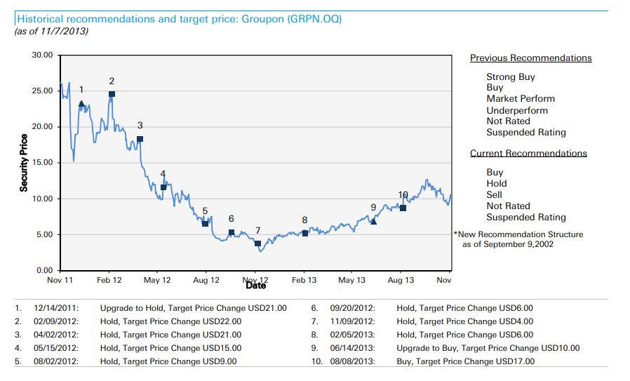Deutsche Bank

JPMorgan

Morgan Stanley

**Part 2**

Question 1

1. What are the general goals and ideals of Groupon in the long term, and what will Groupon do to achieve these said goals and ideals?
2. What new avenues of revenue is Groupon currently developing?
3. Where do we expect to see profit margins to be 6 months from now? A year from now?
4. How does Groupon handle potential setbacks and problems, in the case that these problems do not fix themselves? (Ask for examples in the past)
5. Are there advantages to investing in Groupon as opposed to rival competitors?
6. Explain your business model, and how it would maximize potential profits for investors like me.

Question 2

Using email receipt data could potentially unlock more information about the userbase of Groupon and the patterns/trends of these users.

1. What types of items do these users purchase and who are they purchasing from?
2. Are there any recurring patterns that can tell us about purchases during specific times of day or week in the email receipt data?

Question 3

I believe that email receipt data would be a more accurate representation for tracking Groupon’s North American gross billings because the data encompasses 1 million users from the North American region, whereas the web data has around 140,000 entries of data. The variables that are important in both sets of data are the same: the billing of the deal and the start date of the deal. But because there is simply much more email receipt data than web data, it is easier to draw a less biased conclusion on the general deal trends and patterns.

One pro about web data that is a con in email receipt data is the organization of the deals into three different sections: local, travel, and goods. Having the deals organized like this makes it easier to calculate revenue/profit/billings for each sector in a quarter. Investors would probably want to know the breakdown of the billings and having the data readily available and organized would allow them to easily note and handle the data. One con about the web data given is that it is hard to determine what kind of deals have been made unless one were to go through every deal ID and deal URL, something that is readily available, easily recognizable, and a pro in email receipt data. Having this type of information would tremendously help people analyze popular trends on what people would typically buy on the Groupon. It seems like the strength of one data set would be the weakness of the other one, and vice versa.